|  |  |  |
| --- | --- | --- |
| Taylor Sloan | CSCI 251, Bob Robertson | MWF 2:00-3:30 |
|  |  |  |

1. Identifiers
   1. fahrenheit- Identifier
   2. class- Not Identifier, is a reserved word
   3. x- Identifier
   4. 2x- Not Identifier, must begin with letter or underscore
   5. while- Not Identifier, is reserved word
   6. x2- Identifier
   7. y_2- Identifier
2. No, identifiers are case sensitive
3. 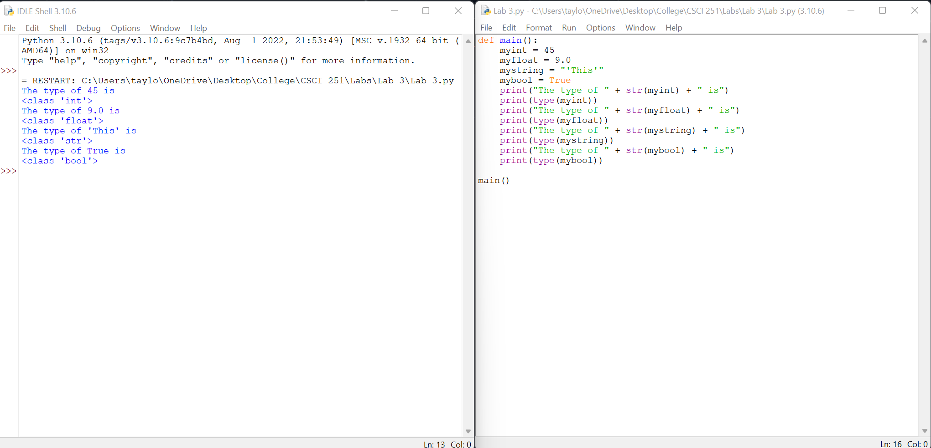
4. 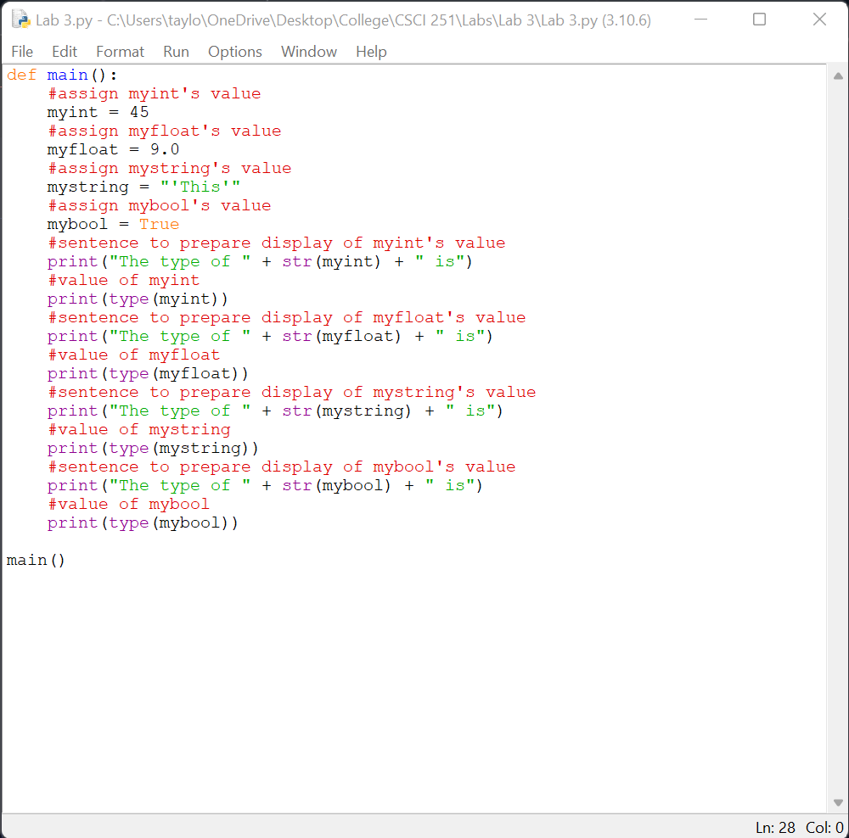
5. Arithmetic
   1. 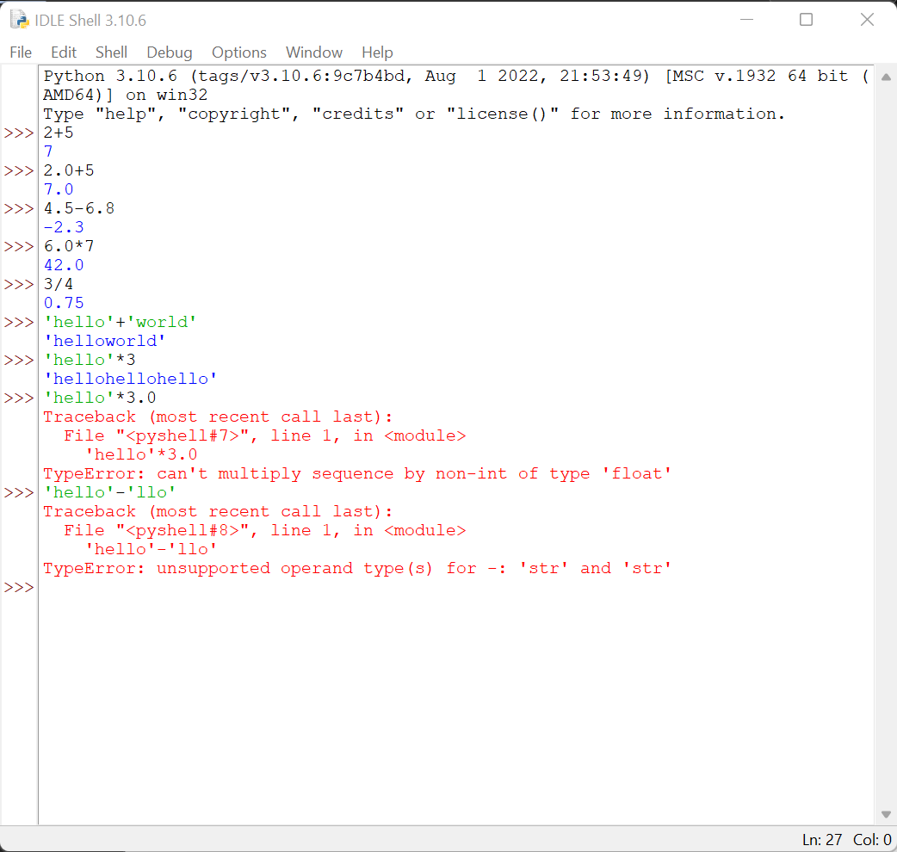
   2. 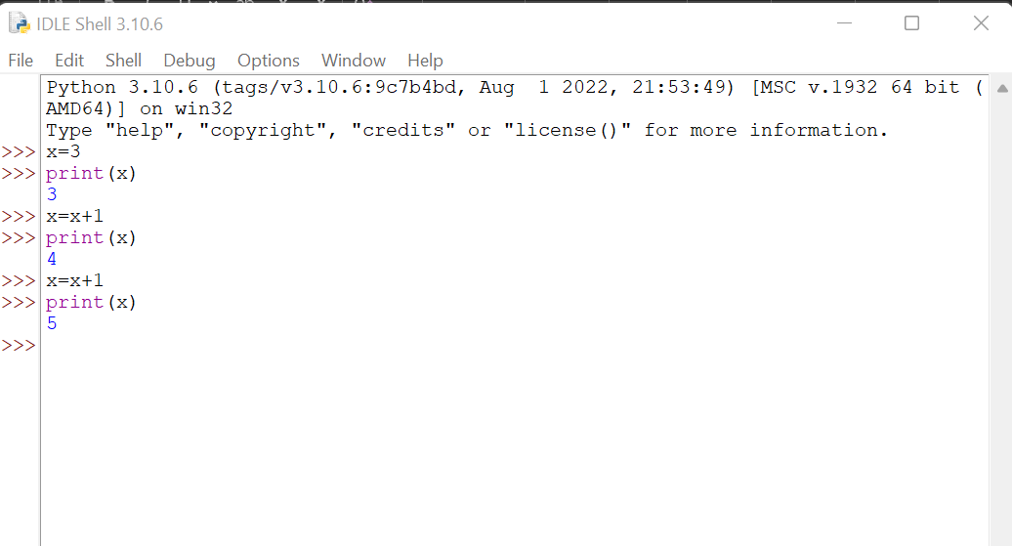
   3. Output will be 40 Graphical user interface, text, application

      Description automatically generated
   4. Output will be 10 Graphical user interface, application, Word

      Description automatically generated